מבוא למדעי המחשב בשפת JAVA

מטלה 4

סטודנטית 1: דליה ויליאם

סטודנט 2: גיא רחמים

Exe_1_TheInvestor

//Dalya William & Guy Rahamim

//Assignment 1

**import** java.util.Scanner;

**public** **class** Exe_1_TheInvestor

{

**public** **static** **void** main(String[] args)

{

//initializing variables.

Scanner input = **new** Scanner(System.***in***);

**float** oldPrice, newPrice;

//ask the user for the old stock price.

System.***out***.println("Please enter the old stock price: ");

oldPrice=input.nextFloat();

//ask the user for the new stock price.

System.***out***.println("Please enter the new stock price: ");

newPrice=input.nextFloat();

//if new price is bigger or equal to the old price

**if** (newPrice >= oldPrice)

{

//print BUY and the difference of new from old.

System.***out***.println( "BUY!");

System.***out***.println("the price difference is :" + (newPrice-oldPrice));

}

**else** //if not

{

//print SELL and the difference of old from new.

System.***out***.println("SELL!");

System.***out***.println("the price difference is: " + (oldPrice-newPrice));

}

input.close();

}

}

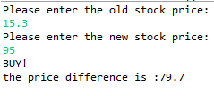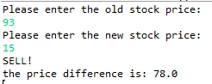

Exe_2_OpeningHours

//Dalya William & Guy Rahamim

//Assignment 2

**import** java.util.Scanner;

**public** **class** Exe2_OpeningHours

{

**public** **static** **void** main(String[] args)

{

//initializing variables.

Scanner input = **new** Scanner (System.***in***);

**int** day=0, visitHour, monday=2,

openingTime=10, closingTime=13;

//taking the day of the users visit to the store

System.***out***.println("Please enter the day of your visit: ");

day = input.nextInt();

//if its not monday, print "we're closed!"

**if** (day!=monday)

{ System.***out***.println("Sorry, we're closed!"); }

**else** //but if it is monday:

{

//take the users time of arrival.

System.***out***.println("Please enter the time of your visit: ");

visitHour = input.nextInt();

//if the visit hour is when the shop is open

**if** (openingTime<=visitHour && visitHour <= closingTime)

{ System.***out***.println("Come in, we're open!"); }

**else** {System.***out***.println("Sorry, we're closed!");}

}

input.close();

}

}

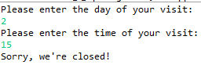

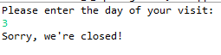

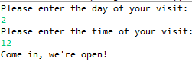

Exe_3_CheckForJava

//Dalya William & Guy Rahamim

//Assignment 3

**import** java.util.Scanner;

**public** **class** Exe3_CheckForJAVA

{

**public** **static** **void** main(String[] args)

{

//initializing variables

Scanner input = **new** Scanner(System.***in***);

**char** checker;

//take a single character from the user.

System.***out***.println("Please enter a letter:");

checker=input.next().charAt(0);

//checks if the letter is either A, J or V and prints "Valid".

**switch** (checker)

{

**case** 'A':

**case** 'J':

**case** 'V':

System.***out***.println("Valid");

**break**;

//if none of the above, print "Invalid".

**default**:

System.***out***.println("Invalid input!");

}

input.close();

}

}



Exe_4_Find7AndCountEven

//Dalya William & Guy Rahamim

//Assignment 4

**import** java.util.Scanner;

**public** **class** Exe4_Find7AndCountEven

{

**public** **static** **void** main(String[] args)

{

//initializing variables.

Scanner input = **new** Scanner (System.***in***);

**int** num, evenCounter=0;

**do** //while loop's body.

{

//taking a number from the user and checks if its even.

//if it is, increase evenCounter by 1.

//this is executed continuously (while loop) until 7 is entered.

System.***out***.println("Please enter a number:");

num=input.nextInt();

**if** (num%2==0) { evenCounter++; }

}

**while** (num!=7); //while loop condition.

//print evenCounter.

System.***out***.println("Number of even numbers entered: " + evenCounter);

input.close();

}

}

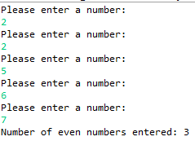

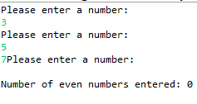

Exe_5_WhatCharAmI

//Dalya William & Guy Rahamim

//Assignment 5

**import** java.util.Scanner;

**public** **class** Exe_5_WhatCharAmI

{

**public** **static** **void** main(String[] args)

{

//initializing variables

Scanner input= **new** Scanner (System.***in***);

**char** userChar;

**final** **char** DIGIT_MIN_LIMIT='0',

DIGIT_MAX_LIMIT='9',

LOWER_CASE_MIN_LIMIT='a',

LOWER_CASE_MAX_LIMIT='z',

UPPER_CASE_MIN_LIMIT='A',

UPPER_CASE_MAX_LIMIT='Z';

//asking the user to input a single character

System.***out***.println("Please enter a single character: ");

userChar= input.next().charAt(0);

//if the character is not a digit or either type of letter, print other.

**if** (userChar < DIGIT_MIN_LIMIT || (DIGIT_MAX_LIMIT < userChar && userChar <UPPER_CASE_MIN_LIMIT))

{ System.***out***.println("Other!"); }

//else, if the character is a digit, print Digit.

**else** **if** (DIGIT_MIN_LIMIT <= userChar && userChar <= DIGIT_MAX_LIMIT)

{ System.***out***.println("Digit!"); }

//else, if the character is a lower case letter, print LowerCase.

**else** **if** (LOWER_CASE_MIN_LIMIT <=userChar && userChar<=LOWER_CASE_MAX_LIMIT)

{System.***out***.println("LowerCase!");}

//else, if the character is an Max case letter, print MaxCase.

**else** **if** (UPPER_CASE_MIN_LIMIT <=userChar && userChar <=UPPER_CASE_MAX_LIMIT)

{System.***out***.println("UpperCase!");}

input.close();

}

}







Exe_6_TipCalculator

//Dalya William & Guy Rahamim

//Assignment 6

**import** java.util.Scanner;

**public** **class** Exe_6_TipCalculator

{

**public** **static** **void** main(String[] args)

{

//initializing variables.

Scanner input = **new** Scanner(System.***in***);

**float** mealPrice, priceIncludingTip=0,

tipMe10=0.10f,

tipMe12=0.12f,

tipMe15=0.15f,

tipMe20=0.20f;

**int** tipAmount;

//taking the price of the users meal.

System.***out***.print("Please enter the price of you meal: ");

mealPrice=input.nextFloat();

//taking the user tip percentage.

System.***out***.println("Plese choose your preferred tip amount in %: ");

System.***out***.println("Tipping options are: 10%, 12%, 15%, 20%");

tipAmount=input.nextInt();

**switch**(tipAmount)

{

**case** (10):

{

//if user chose 10, add 10% to meal price.

priceIncludingTip=mealPrice+(mealPrice*tipMe10);

**break**;

}

**case** (12):

{

//if user chose 12, add 12% to meal price.

priceIncludingTip=mealPrice+(mealPrice*tipMe12);

**break**;

}

**case** (15):

{

//if user chose 15, add 15% to meal price.

priceIncludingTip=mealPrice+(mealPrice*tipMe15);

**break**;

}

**case** (20):

{

//if user chose 20, add 20% to meal price.

priceIncludingTip=mealPrice+(mealPrice*tipMe20);

**break**;

}

}

//print the final meal price, including the chosen tip.

System.***out***.println("The price of your meal including tip is: " + priceIncludingTip);

input.close();

}

}

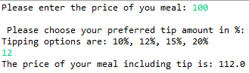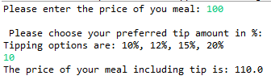

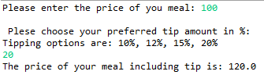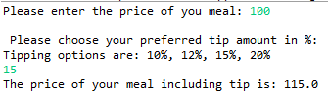

Exe_7_Super7Boom

//Dalya William & Guy Rahamim

//Assignment 7

**import** java.util.Scanner;

**public** **class** Exe_7_Super7Boom

{

**public** **static** **void** main(String[] args)

{

//initializing input.

Scanner input= **new** Scanner (System.***in***);

**int** outerCounter=1, innerCounter=1, digit;

**char** digitBottomLimit=0, digitUpperLimit=9;

// a do while loop that repeats as long as the input

// is not a single digit.

System.***out***.println("Please enter a single digit.");

digit=input.nextInt();

**while** (digit<=digitBottomLimit || digit > digitUpperLimit)

{

//while the input is not a digit

//print bad input and ask for a new entry.

System.***out***.println("Bad input! Please enter a single digit.");

digit=input.nextInt();

}

//the outer counter repeats 100 times.

**while** (outerCounter<=100)

{

//the inner while loop repeats 10 times per cycle, for 10 cycles.

**while** (innerCounter<=10)

{

//if the outer counter % digit = 0, print BOOM.

**if** (outerCounter%digit==0)

System.***out***.print("BOOM , ");

**else** //if not, print the current value of outer counter.

System.***out***.print(" " + outerCounter + " , ");

//increase both counters by 1.

outerCounter++;

innerCounter++;

}

System.***out***.println("");

//set inner counter back to 1 so the

//inner while loop can start over.

innerCounter=1;

}

input.close();

}

}

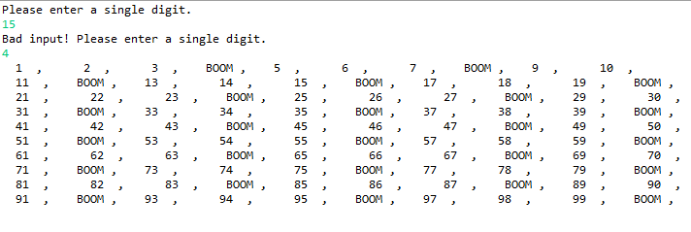

Exe_8_SelfCashRegister

//Dalya William & Guy Rahamim

//Assignment 8

**import** java.util.Scanner;

**public** **class** Exe_8_SelfCashRegister

{

**public** **static** **void** main(String[] args)

{

//initializing variables.

Scanner input = **new** Scanner (System.***in***);

**float** totalPrice=0.f,

currentPrice=0.f,

bambaPrice=3.9f,

cokePrice=4.5f,

bubblegumPrice=1.5f,

icecreamPrice=8.0f;

**char** addRemoveOrSum='0', productSelection;

//boolean that stores if '=' was entered mid loop

**boolean** suddenCheckout=**false**;

System.***out***.println("Welcome to our shop!");

//A while loop asks for a product and an

//action (+,-). then calculates

//total price when user enters =.

**while** (addRemoveOrSum!='=')

{

// suddenCheckout=false;

System.***out***.println("Please Choose a product from the following:"

+ "\n 1.Bamba: 3.9 NIS"

+ "\n 2.Coke: 4.5 NIS "

+ "\n 3.Bubblegum: 1.5 NIS"

+ "\n 4.Icecream: 8 NIS"

+ "\n \n at any stage, press (=) to check out");

productSelection=input.next().charAt(0);

**if** (productSelection >='1' && productSelection <= '4'|| productSelection=='=' )

{

//switch statement that chooses a product.

**switch** (productSelection)

{

**case** '1':

{

System.***out***.println("You chose bamba");

currentPrice=bambaPrice;

**break**;

}

**case** '2':

{

System.***out***.println("You chose coke");

currentPrice=cokePrice;

**break**;

}

**case** '3':

{

System.***out***.println("You chose bubble gum");

currentPrice=bubblegumPrice;

**break**;

}

**case** '4':

{

System.***out***.println("You chose ice cream");

currentPrice = icecreamPrice;

**break**;

}

**case** '=':

{ suddenCheckout=**true**;

}

// if user entered = when choosing a product,

//break out of the loop.

**if** (suddenCheckout==**true**)

**break**;

//asking the user whether to add or remove a product

System.***out***.println("do you want to add the product (+) or remove it (-)?");

addRemoveOrSum=input.next().charAt(0);

**switch** (addRemoveOrSum)

{

**case** '+':

{

totalPrice += currentPrice;

System.***out***.println("Product added!");

**break**;

}

**case** '-':

{

totalPrice-=currentPrice;

System.***out***.println("Product removed!");

**break**;

}

**case** '=':

{ suddenCheckout=**true**; }

}

// if user entered '=' when choosing a product,

//break out of the loop.

**if** (!suddenCheckout)

{

System.***out***.println("Would you like to check out?"

+ "\n if yes, enter =. if not, press any key. \n");

addRemoveOrSum=input.next().charAt(0);

currentPrice=0;//reset currentPrice until it receives a new value.

}

}

**else** System.***out***.println("bad input! please choose a number from 1 to 4");

}

//as long as the user hasn't typed "=", enter the loop again.

System.***out***.println("The total price of your purchase is: " + totalPrice);

input.close();

}

}

